**Screenshot of Assessment Task 2 – Virtual Cluster**

1. **Hypervisor**
2. **Install and configure host systems.**
   1. Installed and configured hypervisors on both computer systems and assigned an IP address to both VM hosts.

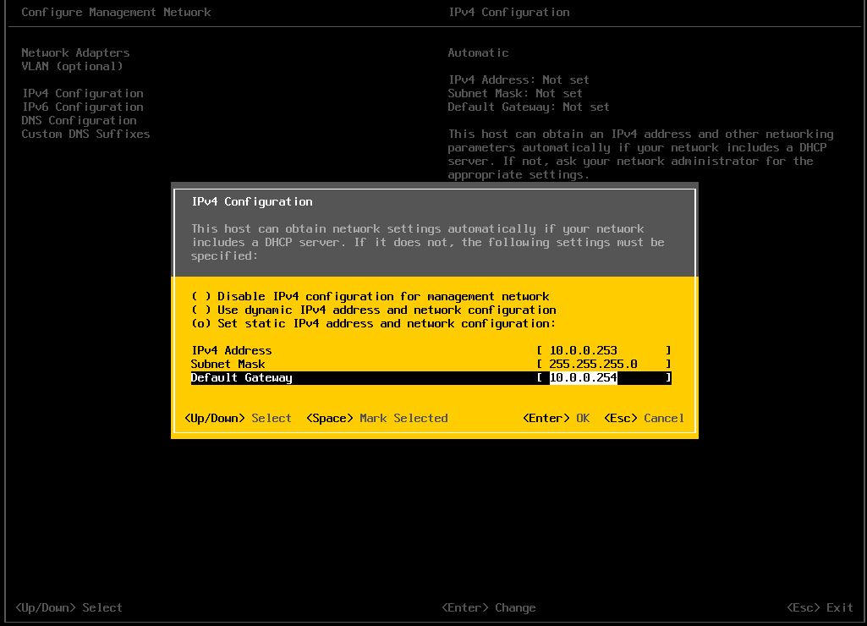

Figure AA-VMhost-1 IP Configuration

Figure AA-VMhost-1 DNS Configuration

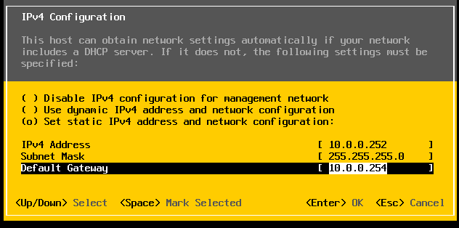

Figure AAVMhost-2 IP Configuration

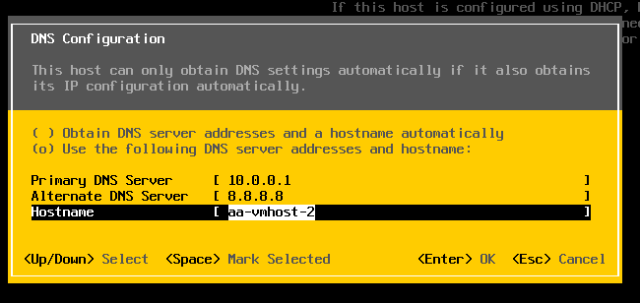

Figure AAVMhost-2 DNS Configuration

* 1. Accessed the remote administration interface of both VM hosts.

Figure aa-vmhost-2 and aa-vmhost-1 access from web browser.

1. **Creating the server infrastructure.**
   1. Uploaded all the installation images (ISOs) to datastores on both VM hosts.

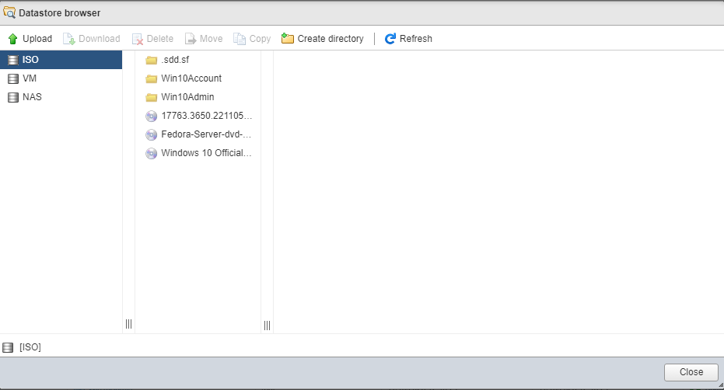

Figure AA-VMhost-1 Installation Images

Figure AA-VMhost-2 Installation Images

* 1. Created the new VMs inside the hosts and install the specified OS on each.

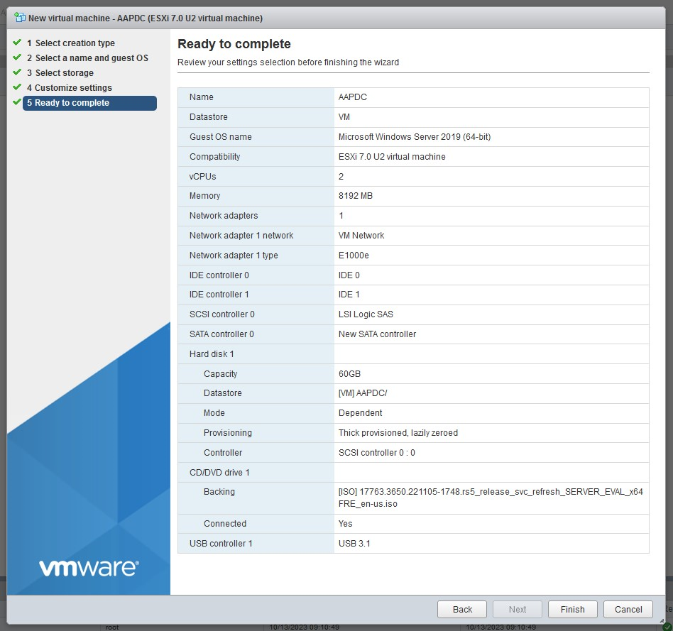

Figure Created AAPDC in aa-vmhost-1

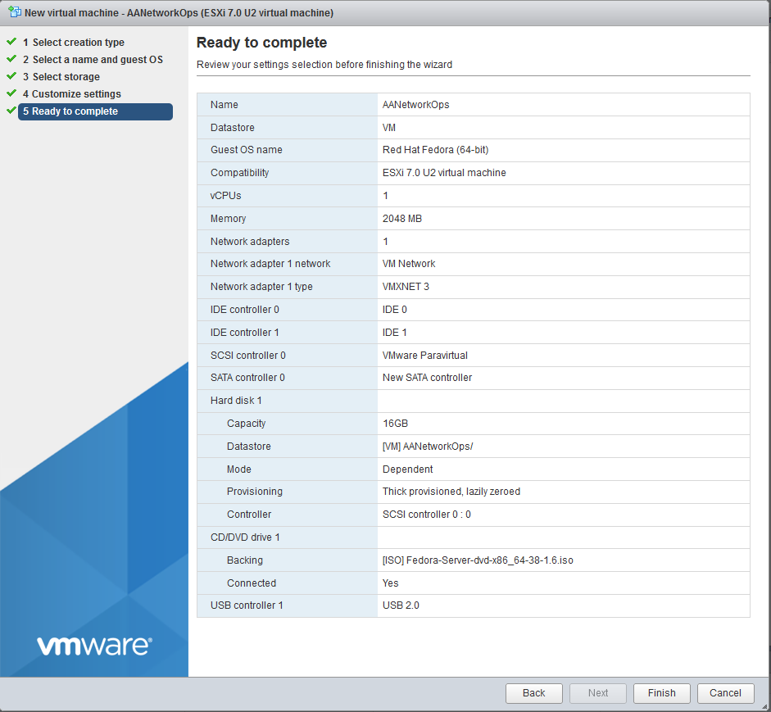

Figure Created AANetworkOps in aa-vmhost-1

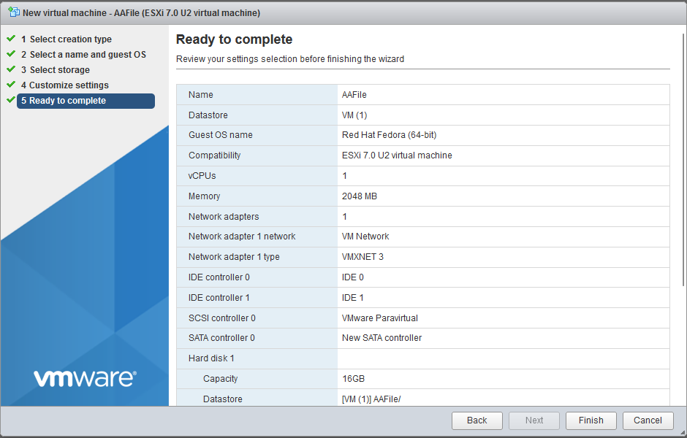

Figure Created AAFile in aa-vmhost-2

Figure Created AABDC in aa-vmhost-2

* 1. Managed the vSwitch connections and assigned IP addresses to the virtual servers.

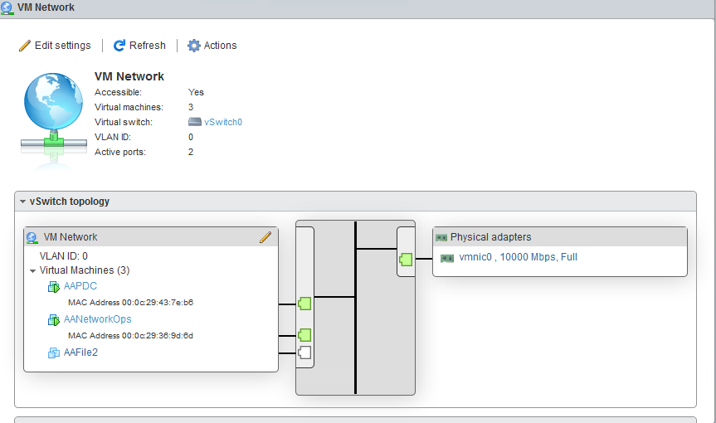

Figure In AA-VMHost-1 the vSwitch0 connected with VM Server

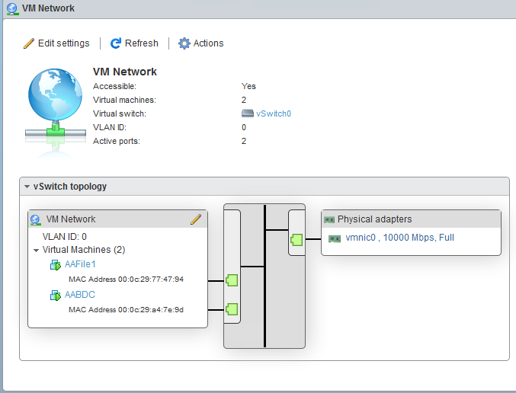

Figure 13 In AA-VMHost-2 the vSwitch0 connected with VM Server

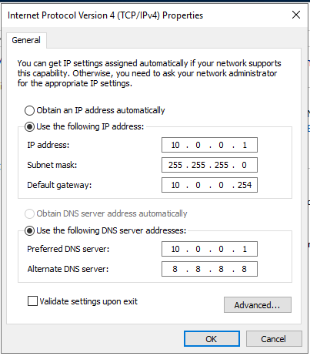

Figure 14 AAPDC IP Address Configuration

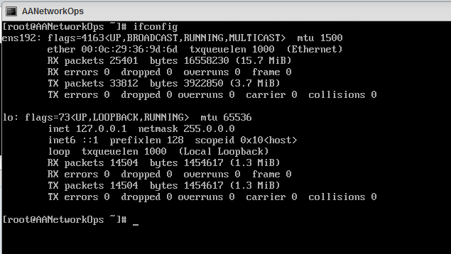

Figure 15 AANetworkOps IP Address Configuration

Figure 16 AAFile IP Address Configuration

Figure 17 AABDC IP Address Configuration

1. **Testing.**

| Test | Description | Action  (how did you test it?) |
| --- | --- | --- |
| 1. Connectivity | 1. Ping client to VMHost-1 and VMhost-2 2. Ping client to all servers 3. Test FTP Connections 4. Test DNS | 1. Using ping command to VMhost-1 and 2 by IP. 2. Using ping command to all servers (Linux Servers and Windows Servers) 3. Using ftp command 4. Using nslookup command |
| 1. Ping client to VMHost-1 and VMHost-2      1. Ping client to all servers  * Ping to Windows server by IP (AAPDC and AABDC)      * Ping to Linux Server by IP (AAFile and AANetworkOps)      1. Test FTP Connections   A computer screen shot of a black screen  Description automatically generated   1. Test DNS | | |
| 1. Availability | 1. Test the availability of web server. 2. Test availability of files/folders 3. Test availability of vCenter Server | 1. Access web server on browser by Domain Name. 2. Access sharing file by Windows Explorer. 3. Access vCenter on browser by Domain Name. |
| 1. Test Web Server      1. Test Files and Folders      1. Test access to vCenter Server | | |
| 1. Performance | 1. Test and monitor the Windows server. 2. Test and monitor Linux server. | 1. Test and monitor the Windows Server  * Install performance Test for test network speed between server and Client. * Run perfmon /report command.  1. Test and Monitor Linux Server  * Run btop command for monitor Linux server. * Run iptraf-ng for monitor network connection. |
| 1. Test and monitor the Windows Server  * Test Network Speed between server and client.      * Run perfmon /report for diagnostics report for monitor Windows Server.      1. Test and monitor Linux Server  * Run btop command for monitor Linux Server      * Run iptraf-ng for monitor Linux Network Connection | | |

1. **Managing the VM infrastructure.**
   1. Cloned a virtual machine.

Figure Clone AAFile

* 1. Created a VM template and deployed a new VM from the template.

Figure Clone AANetworkOps to Template

* 1. Created a VM snapshot and create a resource pool to manage the resources and backing up of the VMs in NAS.

Figure Snapshot AAFile VM

Figure Add NAS to VM

1. **High Availability.**
   1. Created a cluster and configure High Availability and tested by migrating the VMs from.

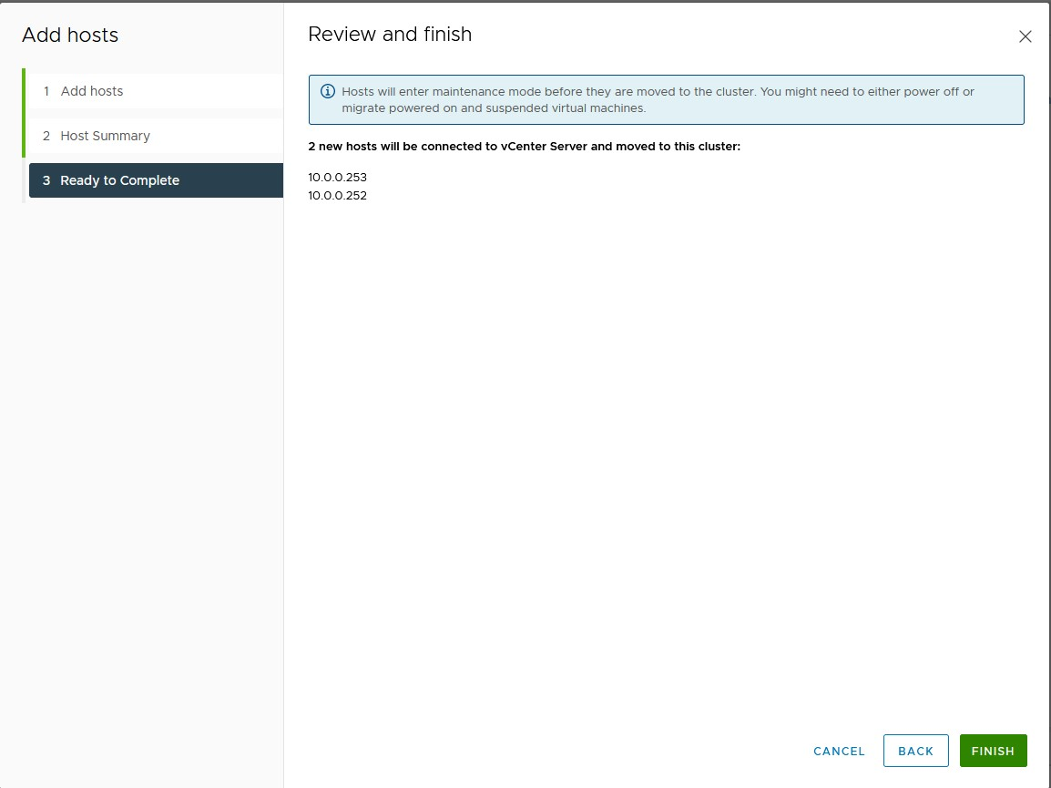

Figure Create a Cluster in vCenter.

1. **Segmenting the Network.**
   1. Created two Microsoft Windows 10 Pro VM and connected to the domain as a user in the accounts section and user from the administration section.

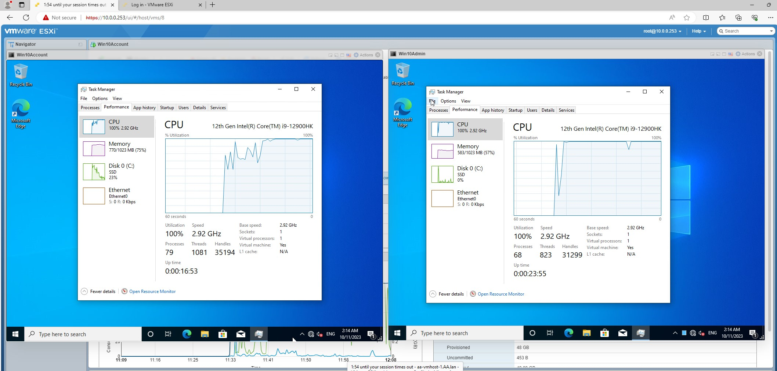

Figure Two Windows 10 Pro VM connected to domain user Account and Administration

* 1. Created a virtual switch and apply two VLAN.

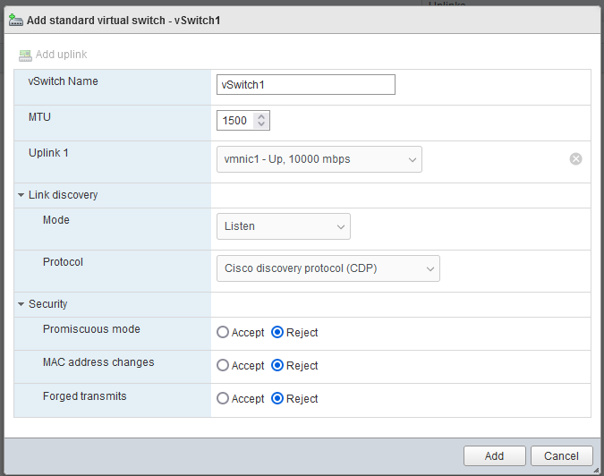

Figure 24 Create vSwitch with high bandwidth for two VLAN.

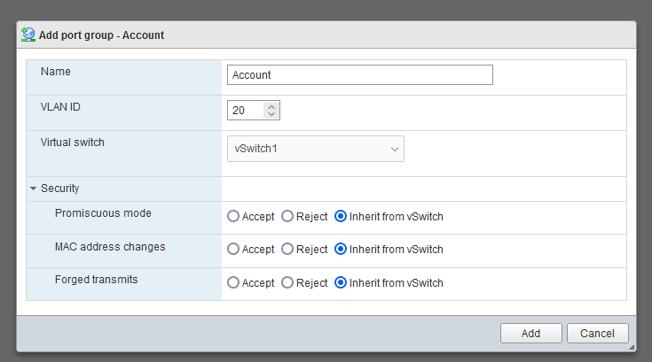

Figure Account vSwitch VLAN 20

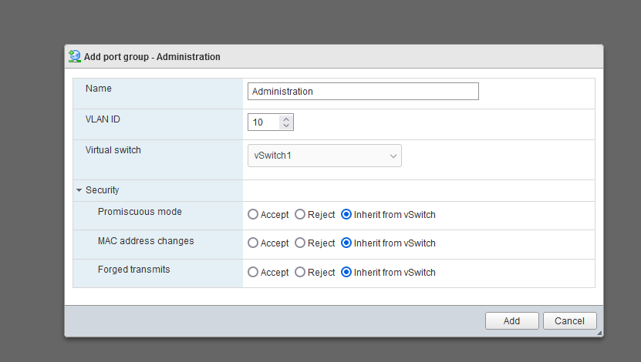

Figure 26 Administration vSwitch VLAN 10

1. **Server Configuration.**
2. **Primary Domain Controller (AAPDC)**

* AAPDC IP setting

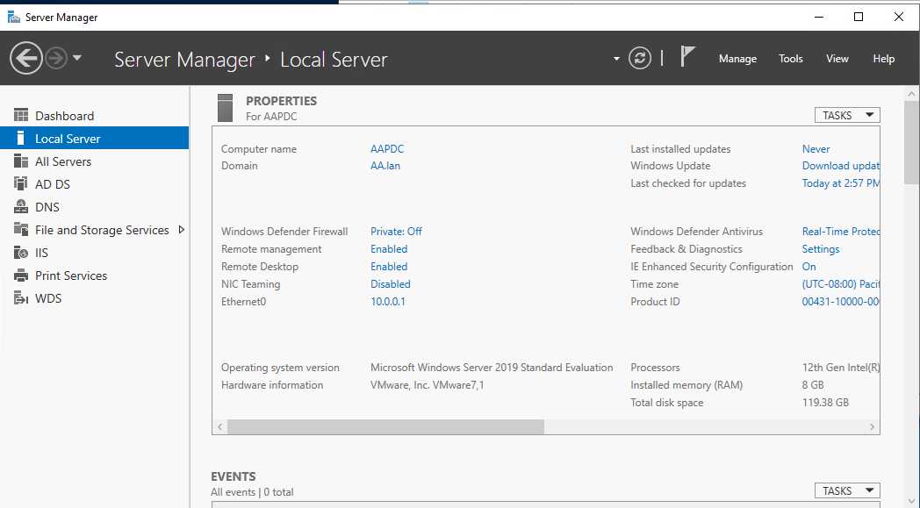

Figure Primary DC IP and Device name setting.

* AA Group, User and Department Creation

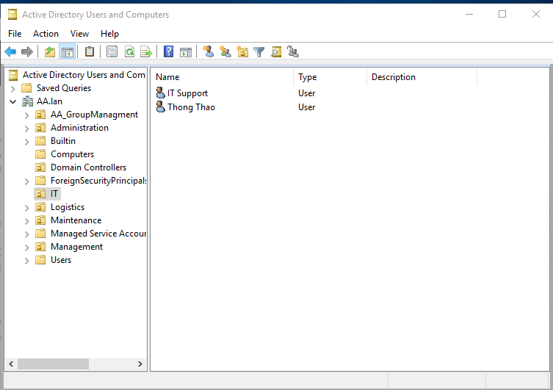

Figure AA Group, User and OU

* Domain Name System (DNS)

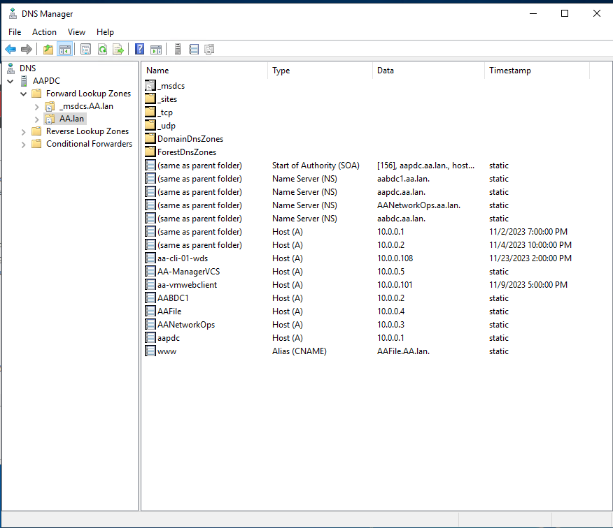

Figure DNS in Primary DC

* DFS

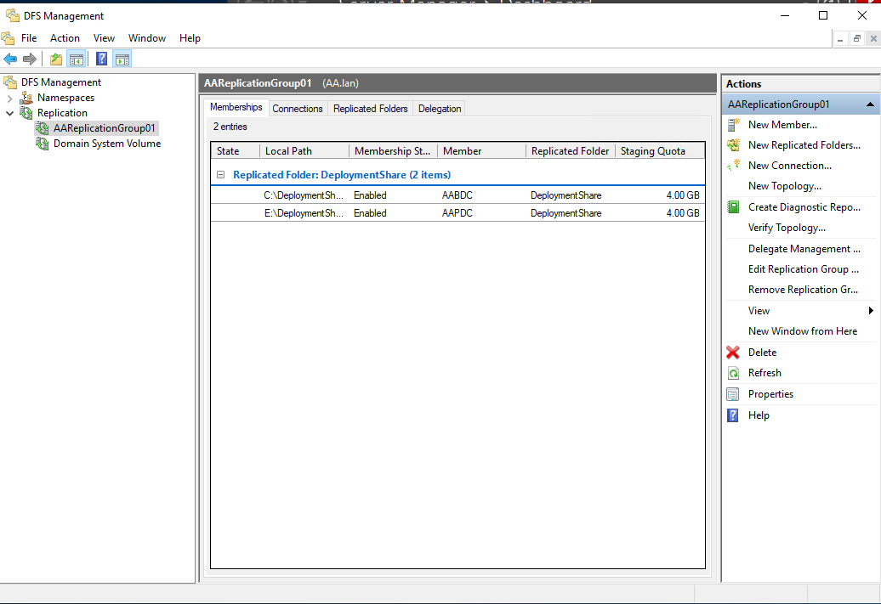

Figure AA Replication between AAPDC and AABDC

* Printer Server

Figure Printer Server Completed setup.

Figure Sharing Printer by Group Policy

* Windows Deployment (WDS)

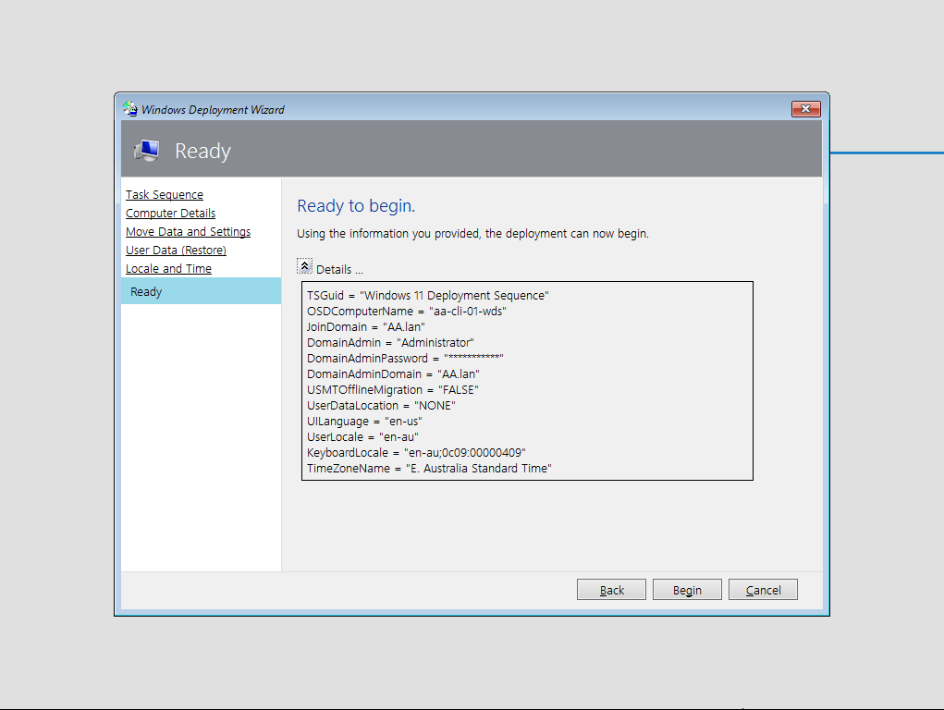

Figure Install Windows 11 by WDS

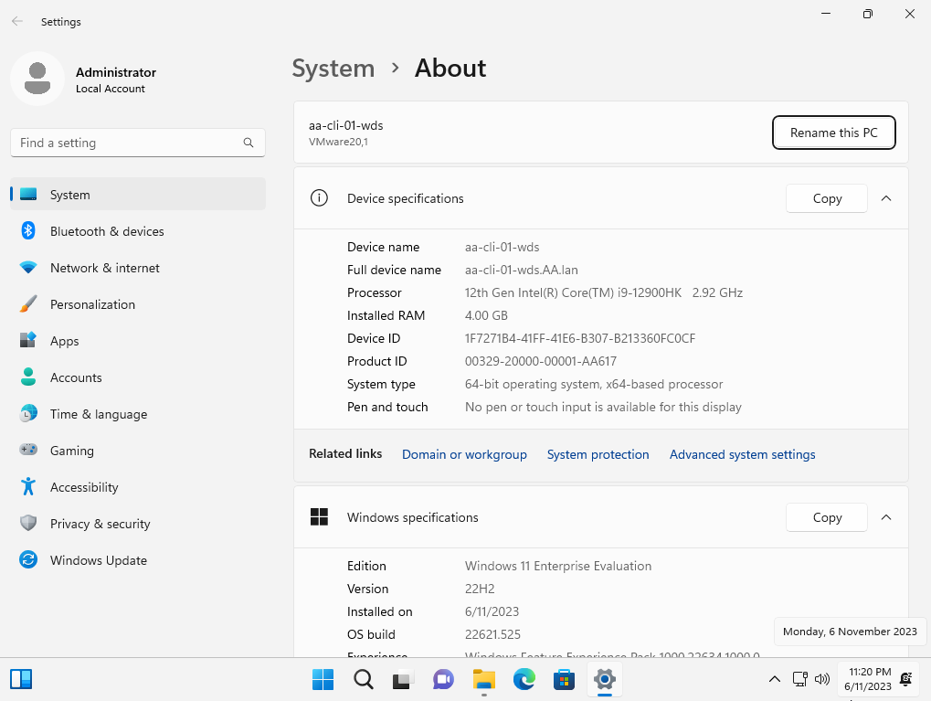

Figure Completed Install Windows 11 by WDS

1. **Secondary Domain Controller (AABDC)**

* AABDC IP setting.

Figure Figure 19 Backup DC IP and Device name setting.

1. **AANetworkOps (Linux Server)**

* DHCP Server

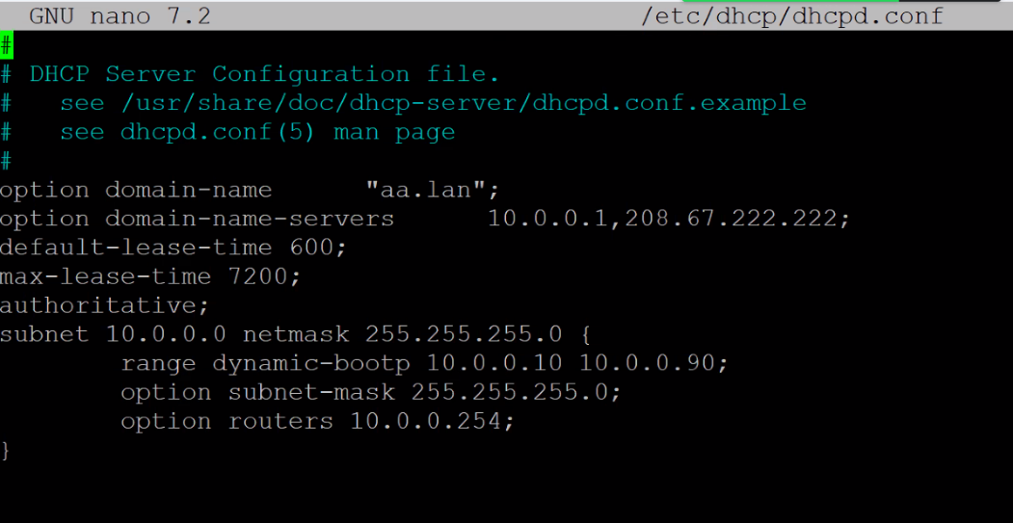

Figure DHCP Server setting up in AANetworkOps

* Domain Name System (DNS of NetworkOps)

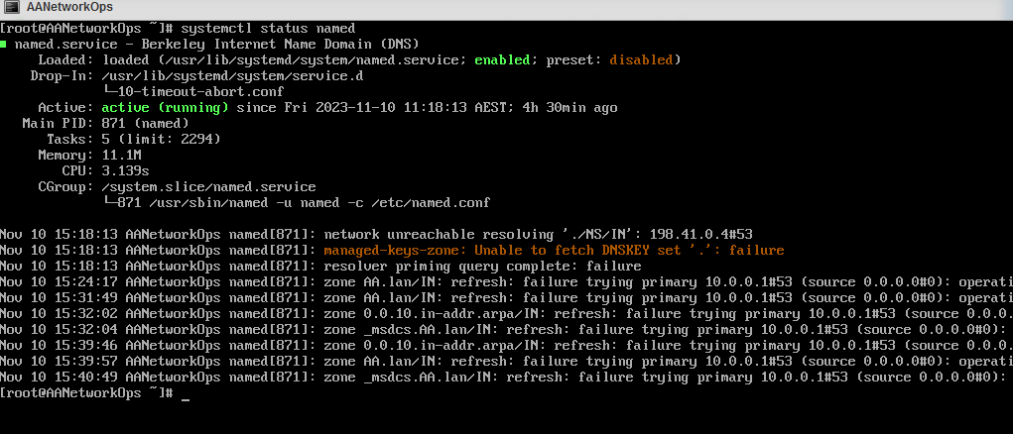

Figure Check DNS status in AANetworkOps

* Join Domain

Figure Join AANetworkOps to Domain Controller

1. **AAFile (Linux Server)**

* Samba (SMB)

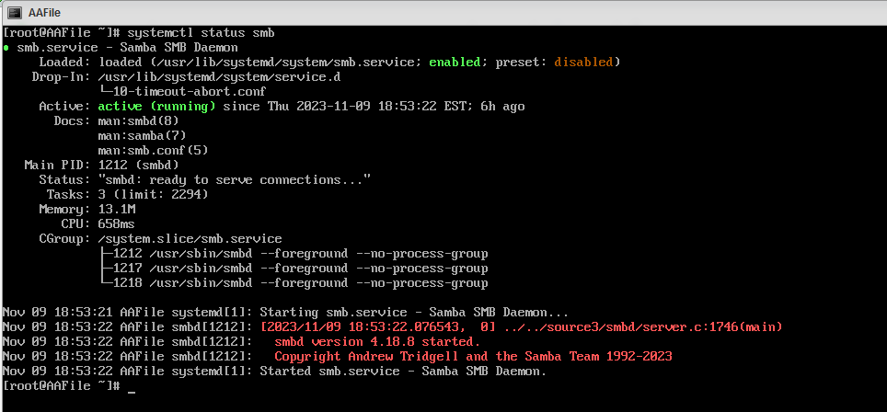

Figure Check samba (SMB) status in AAFile

* File Transfer Protocol

Figure Check FTP status in AAFile

* Web server

Figure Check Web Service status in AAFile

* Join Domain

Figure Join AAFile to Domain Controller

1. **VMware ESXi 7.0.3 (AAVMhost-1)**

* Join Domain

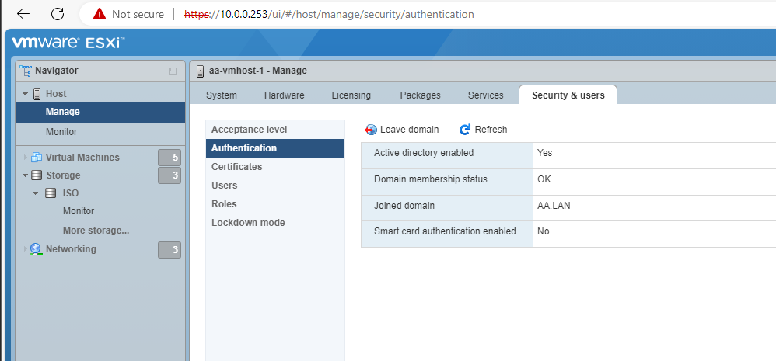

Figure Join AA-VMHost-1 to Domain Controller

1. **VMware ESXi 7.0.3 (AAVMhost-2)**

* Join Domain

Figure Join AA-VMHost-2 to Domain Controller